SOAP UI Testing

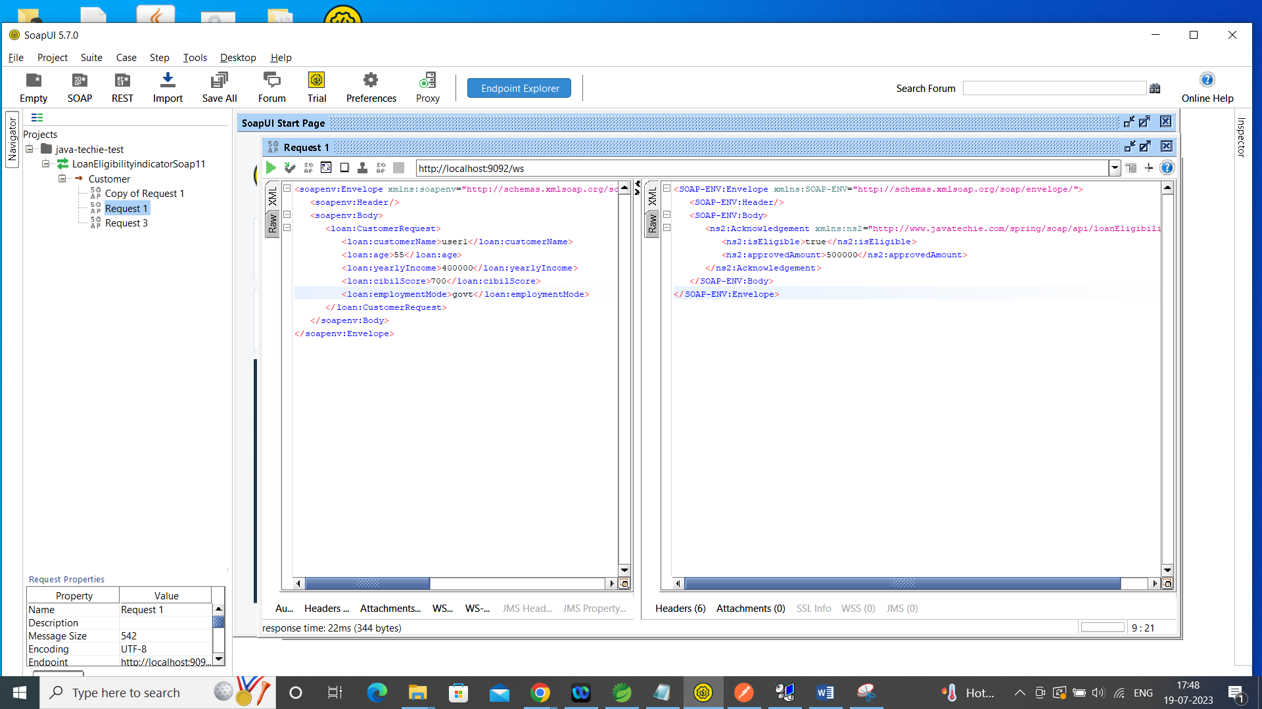

Postman

API Gateway call

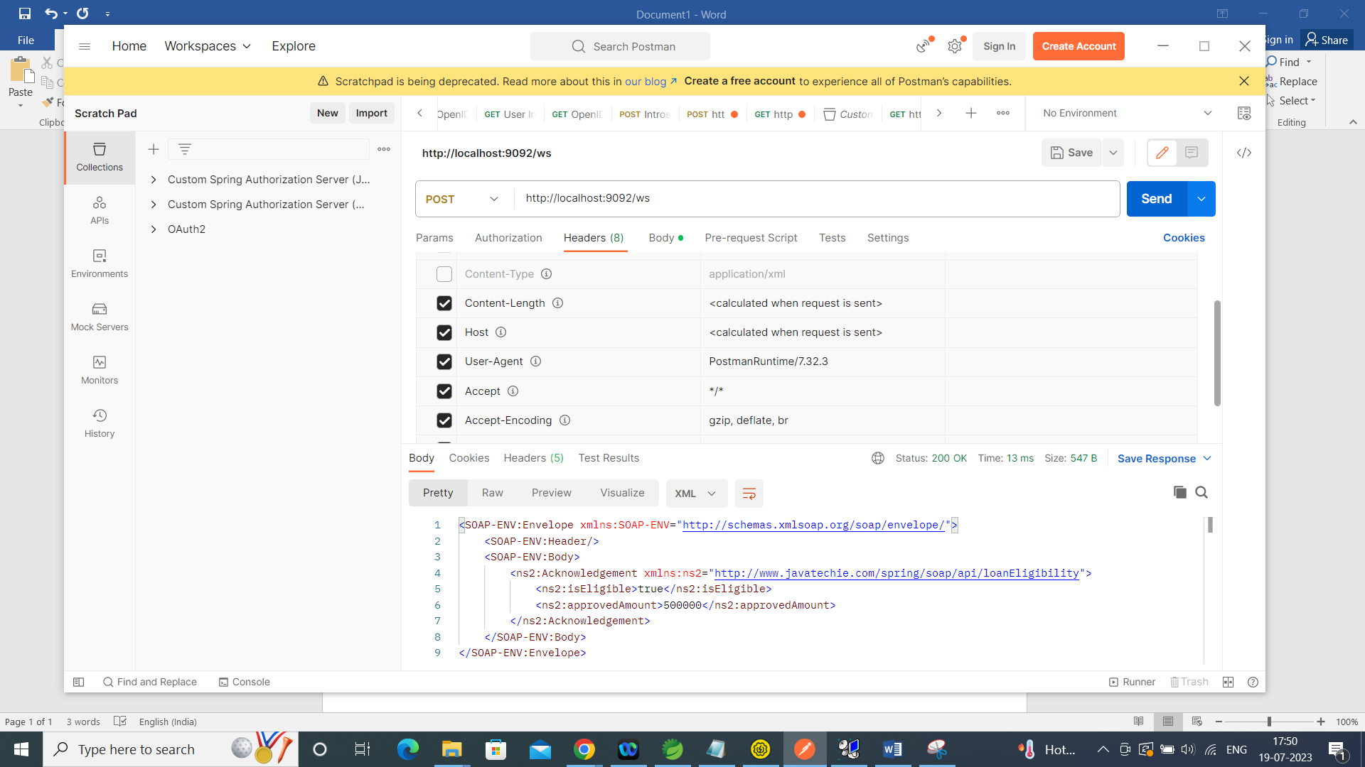

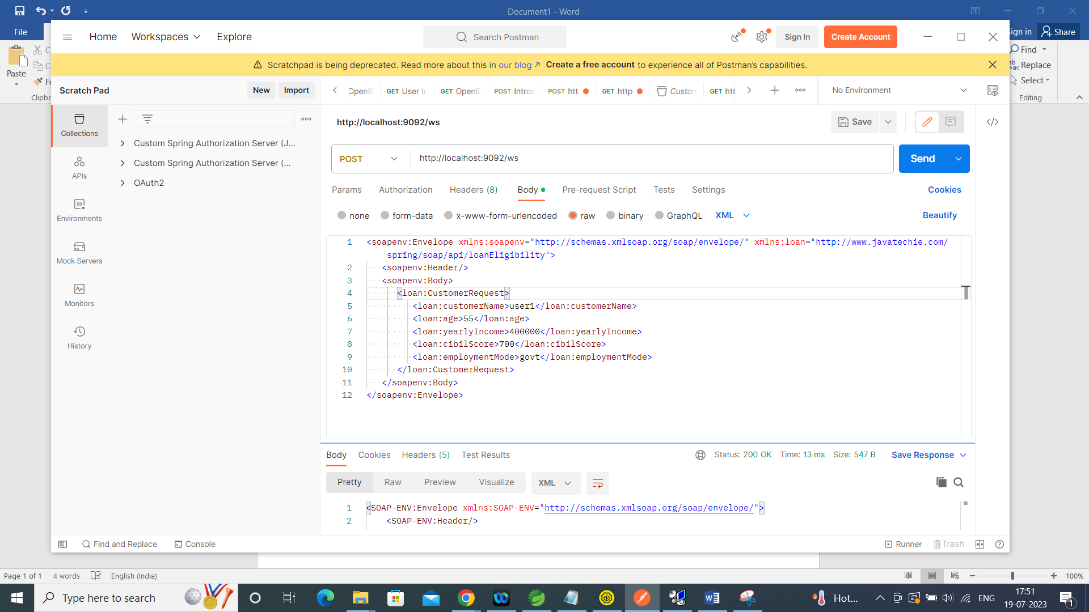

Direct service call

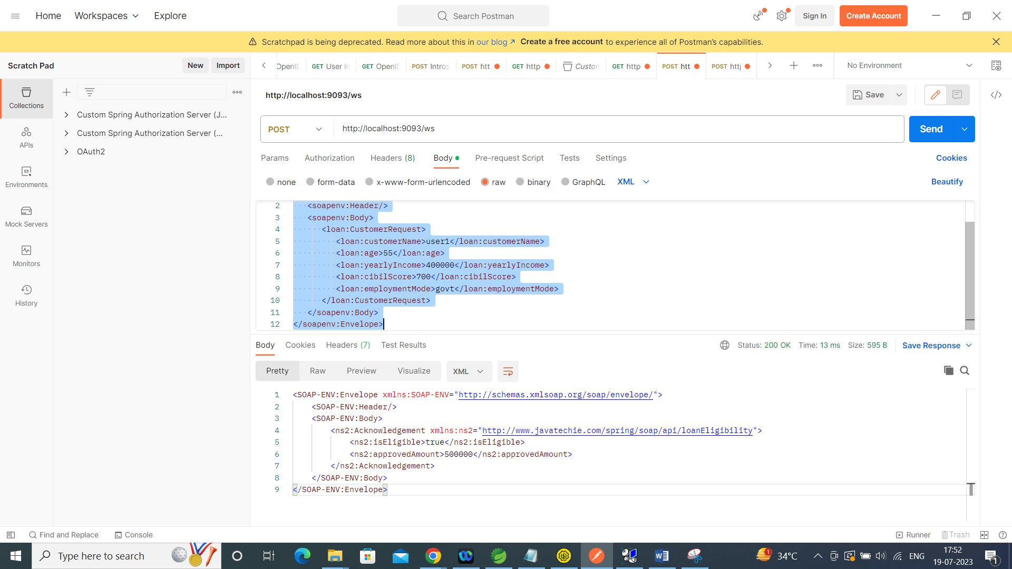

Payload

<soapenv:Envelope xmlns:soapenv="http://schemas.xmlsoap.org/soap/envelope/" xmlns:loan="http://www.javatechie.com/spring/soap/api/loanEligibility">

   <soapenv:Header/>

   <soapenv:Body>

      <loan:CustomerRequest>

         <loan:customerName>user1</loan:customerName>

         <loan:age>55</loan:age>

         <loan:yearlyIncome>400000</loan:yearlyIncome>

         <loan:cibilScore>700</loan:cibilScore>

         <loan:employmentMode>govt</loan:employmentMode>

      </loan:CustomerRequest>

   </soapenv:Body>

</soapenv:Envelope>

Url - <http://localhost:9092/ws> API Gateway url

<http://localhost:9093/ws> service url